How to remove spaces between numbers in Excel

In Excel, you may need to remove extra spaces between numbers when you’re working with numerical data such as performing calculations or creating charts. Extra spaces can interfere with the accuracy of your results. For example, if you have a column of numbers with varying spaces, it may be challenging to perform mathematical operations or apply functions correctly.

The dataset provided below contains information related to 10 orders of supercars in the year 2022. Each order is identified by an Order ID associated with it. The dataset includes details such as the Customer Name, Supercar model, Price (in millions), and Date of Arrival. There are unnecessary spaces between the numbers present in Order IDs and we need to eliminate the spaces between numbers in the Order ID of each order.

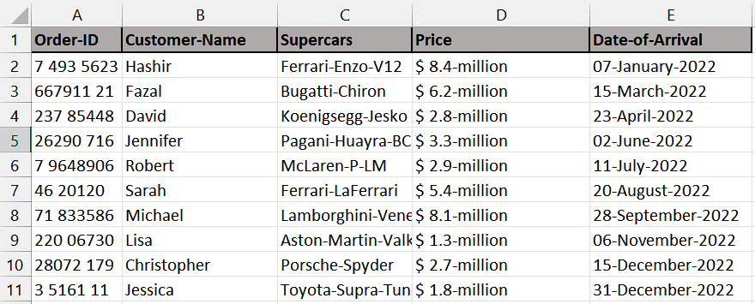

Following are 2 methods to perform our task:

## Method 1 – By using Find and Replace tool

## Step 1 – Selecting the Range of cells

* Select the range of cells in which numbers with spaces are present.
* We selected this range because we want to remove spaces from numbers only present in these cells. If we do not select any particular range then it will remove spaces from all cells in the sheet.



## Step 2 – Opening Find and Replace tool

* Look for the **"Find and Replace"** function.
* In **Microsoft Excel**, you can find it **under the "Home" menu**. It is usually represented by a **magnifying glass icon** or a binoculars icon.
* Click on the **"Replace" option** to open the tool.
* Alternatively, you can press **“Ctrl + H”** on your keyboard to open the **Find and Replace dialog box.**



## Step 3 – Removing the spaces

* After following above step, add a space in the **“Find what” option.**
* Then, leave the **“Replace with” option** empty.
* Now, click on the **“Replace All”** **option** and all spaces will be removed.
* Click on the **OK option** on the dialogue box that has appeared.
* Then, **close** the **dialogue box.**



## Method 2 – By using the SUBSTITUTE Function

## Step 1 – Selecting the cell

* Firstly, **select any empty cell** in which we want to get the numbers without spaces. For example, it is **cell B2** in our case.
* In this selected cell, we will apply the SUBSTITUTE Function to remove spaces.



## Step 2 – Writing and implementing the formula

* After the cell is selected, **press the = (equal sign)** on your keyboard.
* Then, write and select the **SUBSTITUTE Function.**
* Select or **write the name of cell** where the **original text is located**. In this case, it is **cell A2.**
* Then, enter a **comma (,)** which will move you to **next parameter** which is **“old_text”.**
* This is the **argument** within the **SUBSTITUTE function** and **represents** the character or **text you want to replace.** In this case, **it is a space character (" ").**
* After that, enter a **comma (,)** and you will move to **next argument** which is **“new_text”.**
* This is the **next** **argument** within the **SUBSTITUTE** **function** and **represents** the character or **text you want to replace the original character with.** In this case, it is an **empty string ("")** which means you want to **remove the space character.**
* Then, add a **closing parenthesis** and your formula would look like this,

=SUBSTITUTE(A2," ","")

* Now, **press Enter** and all the **spaces** from the **number** **in the cell A2** will be **removed.**



Step 3 – Applying formula to whole range

* **Select the cell** that contains the **formula result**. For example, in our case, it is **cell B2.**
* **Move your cursor** to the **bottom-right corner** of the selected cell. The cursor will change to a **"+" shape**, which is known as the **fill handle.**
* **Double-click** on the **fill handle.** Excel will automatically **apply the formula** to the **entire range** based on the pattern it detects.

